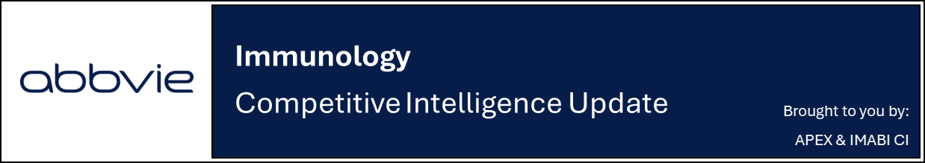

UCB reports positive topline data from
BE BOLD H2H trial in PsA

Company: UCB  Drug: Bimzelx (bimekizumab; SC IL-17A/F) | Date: March 11th, 2026  Source(s): Press Release

What happened:
- UCB announced positive topline results from BE BOLD, a post-marketing trial comparing the efficacy of Bimzelx (bimekizumab; SC IL-17A/F) versus Skyrizi (risankizumab; SC IL-23 mAb) in adult patients with active psoriatic arthritis (PsA), after the topline readout was accelerated to H1 2026 from prior H2 2026 guidance due to strong patient enrollment
  - Results showed statistically significant superiority vs Skyrizi in the primary endpoint of ACR50 at Week 16
  - Treatment with Bimzelx was generally well tolerated, with no new safety signals observed at Week 16
- UCB plans to present the full BE BOLD data at a forthcoming international congress (undisclosed, CI assumes EULAR 2026)

Impact (CI PoV): HIGH
- UCB highlighted BE BOLD as a “landmark” first head-to-head (H2H) study in active PsA to show superiority over an IL-23 inhibitor and the fourth H2H superiority study across the broader bimekizumab psoriatic disease (PsD) program
- Prior Phase 3 H2H studies demonstrating superiority of Bimzelx include BE RADIANT vs Consentyx (secukinumab; SC/IV IL-17 inhibitor), BE-SURE vs Humira (adalimumab; TNFα inhibitor) and BE-VIVID vs Stelara (ustekinumab; SC/IV IL-12/23 mAb)

Why it matters (CI Insights in blue italics):
- Positive topline data is expected to support UCB’s broader positioning of Bimzelx as a first-line treatment across dermatology and rheumatology, potentially strengthening messaging around superiority vs IL-23 inhibition and the joint efficacy enabled by dual IL-17A/F inhibition
- Superiority over Skyrizi in ACR50 at Week 16 may reflect the faster onset typically associated with IL-17 inhibition vs IL-23 blockade; however, the competitive significance of the BE BOLD readout will likely depend on whether Bimzelx demonstrates consistent advantages across additional endpoints (e.g., skin responses, composite disease control), as well as at later timepoints
Tell me more:
- Study Design: The Phase 3b BE BOLD is a multicenter, randomized, double-blind, parallel-group study evaluating efficacy and safety of Bimzelx compared with Skyrizi in adult participants with active PsA
- According to the PR, 553 participants were randomized 1:1 to receive either Bimzelx or Skyrizi (CT.gov shows 684 were enrolled)
- Eligible participants were bDMARD-naïve or had prior exposure to one TNFα inhibitor with an inadequate or intolerant response
- Primary Endpoint: ACR50 at Week 16
- Of note: UCB has begun referring to BE BOLD as a Phase 4 post-marketing study
- Study Results:
- Efficacy: No data was disclosed, with UCB reporting only that Bimzelx achieved statistically significant superiority vs Skyrizi in ACR50 at Week 16
- Safety: Bimzelx was generally well tolerated through Week 16, with no new safety signals observed
- Recall, the most frequently reported AE with Bimzelx across PsD, axSpA, and HS is upper respiratory tract infection, while other common AEs in PsA include oral candidiasis, headache, diarrhea, and urinary tract infection
- Future Outlook:
- Full BE BOLD H2H data is expected at a forthcoming international congress with no details disclosed by UCB; CI anticipates presentation of the full dataset at EULAR 2026
- jPsA and jAS: Phase 3 ongoing (PCD April 2026); topline results anticipated in Q2 2028
- CI estimates US/EU approval in Q2 2029, based on supplemental review assumptions
- Pediatric PsO: BE-TOGETHER Phase 3 study ongoing (PCD August 2028); topline results anticipated in Q4 2028
- CI estimates US and EU approval in Q3 2029 and Q4 2029, respectively, based on supplemental review assumptions

For questions, please reach out to:
 | Dermatology | Rheumatology | Gastroenterology
APEX (US/PCS) | Chanda Bhat | Bethany Christmann | Luke Versten
IMABI (International/ Affiliates) | Priti Anand | Irene Knorn | Priti Anand

Invite your colleagues to inVision | Manage Email Preferences | Unsubscribe

This document contains competitive intelligence collected via AbbVie approved methods or vendors. We collect competitive intelligence consistent with industry standards and AbbVie policy. Not for commercial field use. Please reach out to CI, Legal or OEC with any questions.

